SAMPLE SELLER AND INVENTORY RECORDS
Seller and Inventory Management System
1. Aim
To insert sample seller and inventory records into the E-Commerce Database using SQL INSERT statements.
2. Introduction
Sample data insertion is used to add records into database tables. In this project, seller details and inventory information are inserted into the Seller and Inventory tables.
3. Seller Table
The Seller table stores information about sellers, including Seller_ID and Seller_Name.
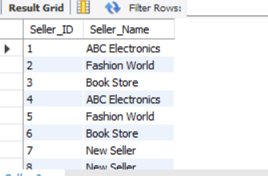

4. Inventory Table
The Inventory table stores product stock details, seller information, reorder level, and last updated date.
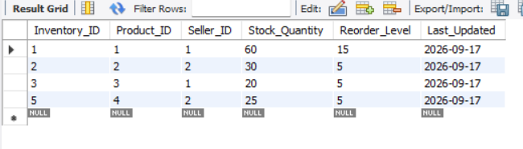

5. Sample Seller Records
Seller_ID | Seller_Name
1 | ABC Electronics
2 | Tech World
3 | Digital Store

6. Sample Inventory Records
Inventory_ID | Product_ID | Seller_ID | Stock_Quantity | Reorder_Level | Last_Updated
1 | 1 | 1 | 50 | 10 | 2026-09-17
2 | 2 | 2 | 30 | 5 | 2026-09-17
3 | 3 | 3 | 20 | 5 | 2026-09-17

7. Importance
Sample data helps to test database operations and verify the relationship between Seller, Product, and Inventory tables.

8. Result
Thus, sample seller and inventory records were inserted successfully into the E-Commerce Database.

